COMP 7500 Lecture 31: File-System Design
: >85%, : 70-85%, : 55-70%, : 40-55%, : < 40%

Exercise 1 (Group Discussion): Please separate the file system layers into the presentation, logic, and data tiers. (Hint: You should pay attention to the boundaries between the file system and the other systems.)
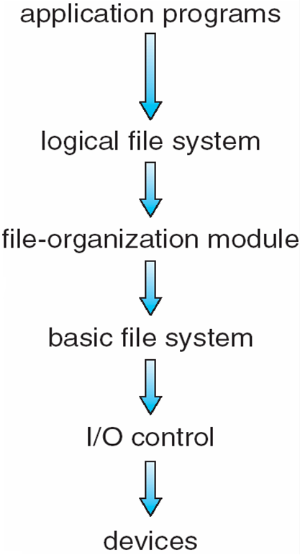

Exercise 2 (Menti): Which layer should take the above two responsibilities?
(A) Logical File System
(B) File-Organization Module
(C) Basic File System
(D) I/O Control

Exercise 3: What is the main purpose of the file-organization module? (Hint: You should focus on physical and logical blocks.)

Exercise 4 (Group Discussion): What are functionalities of the logical-file-system layer? (Hint: Metadata)

Exercise 5: What volume details should be contained in the volume control block? (Hint: superblock and master file table)

Exercise 6: What information should be contained in a file control block?

Exercise 7 (Menti): What is a problem with the single-level directory?

- Difficult to implement
- Difficult to search the directory
- Naming and grouping problem
- Overhead is high

Exercise 8 (Menti): Which statement about linked lists is incorrect?

- Each block contains a header with
  - Number of bytes in the block
  - Pointer to next block
- Blocks need not be contiguous
- Files can expand and contract
- Seeks are fast

